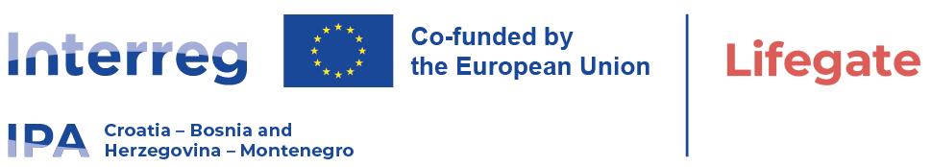

International Open Tender within project LIFEGATE
Date: Novemeber, 11. 2025.

Publication reference: 01-11-10013/25
Contract title: Procurement of sophisticated medical equipment - stereotactic linear accelerator – LINAC
University Clinical Hospital Mostar is announcing a call for a International Open Tender procedure for " Procurement of sophisticated medical equipment - stereotactic linear accelerator – LINAC" within the project "LIFEGATE", HR-BA-ME00489 which is Co-funded by the Interreg VI-A IPA Programme Croatia - Bosnia and Herzegovina - Montenegro 2021-2027.
The supply contract notice and tender dossier are availble from:
- University Clinical Hospital Mostar website: https://www.skbm.ba/javne-nabave/
- EU tenders, Ted - tenders electronic daily: https://ted.europa.eu/en/notice/-/detail/746768-2025
TED Notice publication number: 746768-2025
OJ S issue number: 217/2025
- https://interreg-hr-ba-me.eu/project/procurements-tenders/
- University Hospital Centre Zagreb: https://www.kbc-zagreb.hr/
- Clinical Center of Montenegro: https://www.kccg.me/
- University Hospital of Split: https://www.kbsplit.hr/en
- Public Health Institute of the Republika Srpska: https://www.phi.rs.ba/
- Institute for Public Health, Podgorica: https://www.ijzcg.me/
- Faculty of Medicine, Banjaluka: https://med.unibl.org/

The deadline for submission of tenders is: 12. January 2026 at 10:00 local time.

